**Client:** _____

**Address:** https://rb.gy/go12sl  
**Date:** (day created in the code)

**­­**

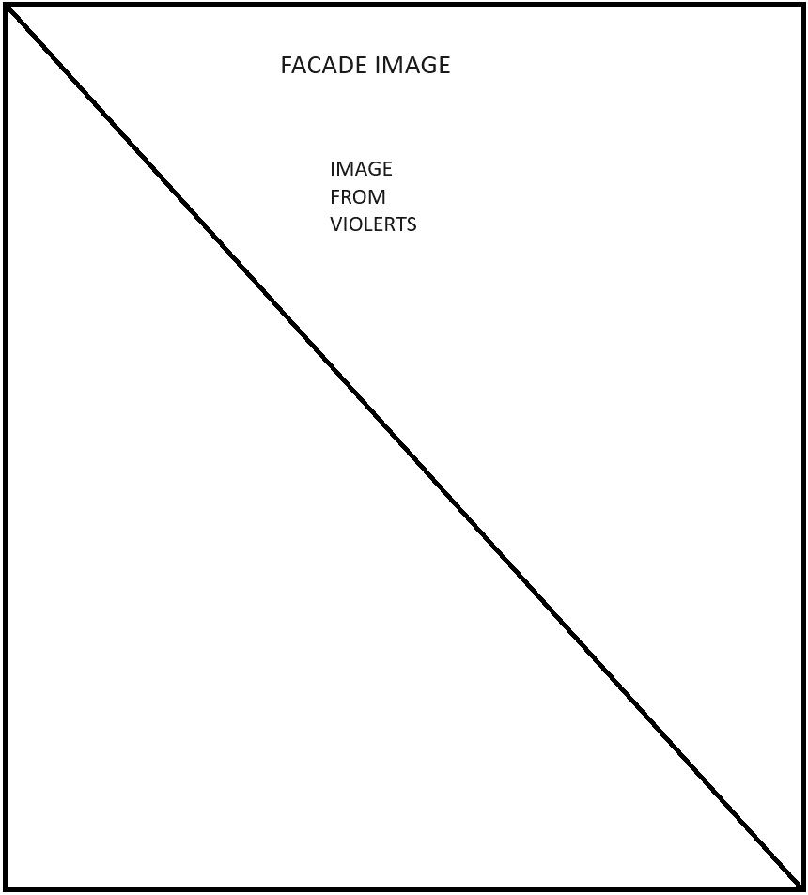**­**



**INDEX**

**I. Property, Building & Site Information___________________________________________ 3**

1. **Address / A.K.A.**
2. **­­­Bin #**
3. **Site Information / District**
4. **Building Information**
5. **Primary Zoning**
6. **Owner Information**
7. **Property Specific Restrictions**
8. **Neighborhood Information**
9. **Floor Area Ratio (FAR)**

**II. Compliance Records_________________________________________________________ 6**

1. **Certificate of Occupancy / Property Card / Icard**
2. **Open Items**
3. **Closed Items**
4. **Applicable Local Regulations**
5. **FDNY**
6. **LPC**

**III. Easements and Agreements__________________________________________________ 8**

1. **Declaration of Easement / Liens**
2. **License Agreement**
3. **Property Title**
4. **Department Requests**
5. **Liens**

**IV. Appendix____________________________________________________________________ 9**

1. **Site Photos**
2. **Historical Photos**
3. **Microfilm**
4. **Acronym Glossary**
5. **Disclosures**

**Yellow = Have**

**Red = Only for certain cases**

**Green = Needs Algorithm**

**Pink = Services Required**

**I.** **Property,** **Building & Site Information**

1. **Address**

* House #: ________________ https://rb.gy/go12sl
* Street Name: ________________ https://rb.gy/go12sl
* Road Type: ________________ **__**
* City, State, Zip Code: _______ https://rb.gy/go12sl
* Borough: ________________ https://rb.gy/go12sl
* District: ________________ https://rb.gy/go12sl

1. **City Record #’s**

* DOB Bin#: ________________ https://rb.gy/go12sl
* LPC Docket #: ________________ https://data.cityofnewyork.us/Housing-Development/LPC-Permit-Application-Information/dpm2-m9mq/about_data
* HPD Registration #:____________ https://data.cityofnewyork.us/Housing-Development/Buildings-Subject-to-HPD-Jurisdiction/kj4p-ruqc/about_data
* FDNY Account #:_______________ **__**

1. **Site Information / District**

* Block #: _______________ https://rb.gy/go12sl
* Lot #:_______________________ https://rb.gy/go12sl
* Lot Area: _______________ https://data.cityofnewyork.us/resource/8y4t-faws.json
* Lot Size: _______________ https://data.cityofnewyork.us/resource/8y4t-faws.json
* # of Bldgs on Lot: ______ https://data.cityofnewyork.us/resource/8y4t-faws.json
* Max. Allow. Bldg Height: ______ **__Needs Disclaimer (needs to be verified)**
* Existing Building Height: ______ **__Needs Disclaimer (needs to be verified)**
* Landmark Status______________ https://rb.gy/go12sl
* FDNY Fire District______________ **__**
* FEMA Flood Zone______________ **__**

1. 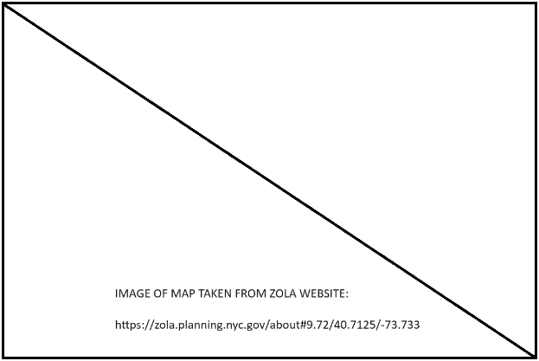**Primary Zoning** (See Zoning Resolution)
   * Zoning Map #: _________________https://data.cityofnewyork.us/resource/fdkv-4t4z.json
   * Primary District:________________ https://data.cityofnewyork.us/resource/fdkv-4t4z.json
   * Special Purpose District**:**_________ https://data.cityofnewyork.us/resource/fdkv-4t4z.json
   * Special District Regulations:______ **__**
   * Height Restriction:_______________ **__**
   * Setback Restriction:______________ **__**
   * District Type:____________________ https://rb.gy/l35d63
   * Open Space regulations:__________ **__**
   * Use Group:______________________ **__ Needs Disclaimer (needs to be verified) Can have multiple**
   * [ZOLA Zoning Map](https://zola.planning.nyc.gov/about#10.06/40.6261/-73.75)________________

**Yard Regulations**

* Front Yard Setback_______________ **__ Needs Disclaimer (needs to be verified)**
* Rear Yard Setback_______________ **__ Needs Disclaimer (needs to be verified)**
* Side Yard Setback_______________ **__ Needs Disclaimer (needs to be verified)**

1. **Owner Information**
   * Current Owner:__________________ https://data.cityofnewyork.us/resource/8y4t-faws.json
   * Previous Owner:_________________ **__**
   * Year Purchased:_________________ **__**
   * Entity Type: ____________________ **__**
2. **Neighborhood Information**

* Community Board #:_____________ https://rb.gy/l35d63
* City Council District#:____________ https://rb.gy/l35d63
* School District:__________________ https://rb.gy/l35d63
* Police Precinct:__________________ https://rb.gy/l35d63
* Fire Company:___________________ https://rb.gy/l35d63
* Sanitation Borough:______________ https://rb.gy/l35d63
* Sanitation District:_______________ https://rb.gy/l35d63
* Sanitation Subsection:____________ https://rb.gy/l35d63
* Local Law_______________________ https://rb.gy/go12sl

1. **Building Information**

**Building Area**

* Total current Floor area: ________ https://data.cityofnewyork.us/resource/8y4t-faws.json **Needs Disclaimer (needs to be verified)**
* Special Purpose District: _________ **__**
* Specific Property Designation:_____ **__**
* **Use Group Defined:**
* Loft Law: ______________________ https://rb.gy/go12sl
* Loft Law Classification:___________ **__Same as district if Loft Law Exists**
* Loft Board Registration:__________ **__Reg Number (look for)**
* **Loft Law Building Defined:**
* Building Classification (NYC DOF):_https://rb.gy/l35d63
* Built (FAR): _________________ https://rb.gy/l35d63 **Needs Disclaimer (needs to be verified)**
* Allowable (FAR):________________ https://rb.gy/l35d63 **Needs Disclaimer (needs to be verified)**
* Allowable building area:_________ https://rb.gy/l35d63 **Needs Disclaimer (needs to be verified)**
* Allowable additional area:_______ https://rb.gy/l35d63 **Needs Disclaimer (needs to be verified)**
* Additional Air Rights:____________ **__**

**Year Built (if before 2012 then have to request) – if not then try to populate**

* Year Constructed: ___________________ https://rb.gy/l35d63
* Latest CO/ Previous CO:_______________ **__**
* Building Code during construction: **__**
* Applicable NYC Building Code: **__**
* Applicable Fire, Plumb., Mech., ADA **__**

**Building Frontage**

* Length of Street Frontage:_____________ **__**
* Street Name of Frontage:______________ **__Street Name**
* Cross Street(s): ______________________ https://rb.gy/go12sl
* Linear feet to nearest corner:__________ **__Reach out for info**
* Sidewalk width:______________________ **__ROFI**
* Curb Cut:____________________________ **__ROFI**
* Sidewalk Vault:______________________ **__ROFI**
* FDNY Connection:____________________ **__ROFI**
* Fire Escape:_________________________ **__ROFI**

**Stories**

* Stories(Above Grade)_________________ https://rb.gy/l35d63
* Stories (Below Grade)_________________ https://rb.gy/l35d63
* Occupancy by Floor:*__________________* **__ ROFI**
* Finished Ceiling Height:_______________ **__ ROFI**

**Units**

* Total Units:__________________________ https://rb.gy/l35d63
* HPD Multiple Dwelling:________________ https://rb.gy/361nqj
* Allowable future Dwelling Units:________ **__**
* Rent Controlled / Rent Stabilized:_______ https://rb.gy/lnax4v
* Dept. Homes and Comm. Renewal:_____ **__Based on Data (awaiting to find out)**
* CONH Certificate:_____________________ **__**

**Building Construction Class**

* Construction Classification:____________ **__**
* Fire Systems

Fire Smoke Detector: _________________ **__**

Fire Alarm:__________________________ **__**

Fire Suppression Systems

-Sprinkler: _________________ **__**

-Ancillary Suppression:_______ **__**

**Building Tax Class**

* Building Classification[DOF]:___________ https://data.cityofnewyork.us/City-Government/Property-Valuation-and-Assessment-Data-Tax-Classes/8y4t-faws/about_data
* Tax Class:___________________________ https://data.cityofnewyork.us/City-Government/Property-Valuation-and-Assessment-Data-Tax-Classes/8y4t-faws/about_data
* Tax Rate:____________________________ **__**

**Utilities**

* Electrical Service:_____________________ **__**
* Gas Service:_________________________ **__**
* Water Service: _______________________**__**
* Water Heaters:_______________________ **__**
* Sewer System:_______________________ **__**

**Systems**

* Rooftop water tank: __________________ **__**
* Heating System:______________________ **__**
* HVAC Service(Main):__________________ **__**
* Secondary Air Conditioning____________ **__**
* Conveyance Systems: ________________ **__**
* Sidewalk Vault:______________________ **__**

**Appliances**

* Gas Stoves__________________________ **__**
* Washing Machine____________________ **__**
* Dishwashers_________________________ **__**

**II.** **Compliance Records (Just a count of amount of each not literal list of items)**

1. **Certificate Of Occupancy / Property Card / I-card**
   * CO:____________________________ https://data.cityofnewyork.us/Housing-Development/DOB-Certificate-Of-Occupancy/bs8b-p36w/about_data
   * Description of use________________ **__**
   * Use by floor_____________________ **__**
   * Date Issued_____________________ **__**
   * Special Provisions________________ **__**
   * I-Card(1902)____________________ **__**
   * Property Card___________________ **__**
2. **Closed Items**

**Previous Notable DOB Application #1**

* + Job #:__________________________ https://data.cityofnewyork.us/Housing-Development/DOB-Job-Application-Filings/ic3t-wcy2/about_data
  + Job Type:_______________________ https://data.cityofnewyork.us/Housing-Development/DOB-Job-Application-Filings/ic3t-wcy2/about_data
  + Job Status:______________________ https://data.cityofnewyork.us/Housing-Development/DOB-Job-Application-Filings/ic3t-wcy2/about_data
  + Job Description:__________________ https://data.cityofnewyork.us/Housing-Development/DOB-Job-Application-Filings/ic3t-wcy2/about_data
  + Job Withdrawn on:_______________ https://data.cityofnewyork.us/Housing-Development/DOB-Job-Application-Filings/ic3t-wcy2/about_data
  + Prev. Applicant/Architect:_________ **__**

**Previous Notable DOB Application #2**

* + Job #:__________________________ https://data.cityofnewyork.us/Housing-Development/DOB-Violations/3h2n-5cm9/about_data
  + Job Type:_______________________ https://data.cityofnewyork.us/Housing-Development/DOB-Violations/3h2n-5cm9/about_data
  + Job Status:______________________ https://data.cityofnewyork.us/Housing-Development/DOB-Violations/3h2n-5cm9/about_data
  + Job Description:_________________ https://data.cityofnewyork.us/Housing-Development/DOB-Violations/3h2n-5cm9/about_data
  + Job Disapproved on:______________ https://data.cityofnewyork.us/Housing-Development/DOB-Violations/3h2n-5cm9/about_data
  + Prev. Applicant/Architect:_________ **__**

**Emergency Repairs Violation Search**

* + Work Order #:___________________ https://data.cityofnewyork.us/Housing-Development/Open-Market-Order-OMO-Charges/mdbu-nrqn/about_data
  + Work Order Description:__________ https://data.cityofnewyork.us/Housing-Development/Open-Market-Order-OMO-Charges/mdbu-nrqn/about_data
  + Work Order #:___________________ https://data.cityofnewyork.us/Housing-Development/Open-Market-Order-OMO-Charges/mdbu-nrqn/about_data
  + Work Order Description:__________ https://data.cityofnewyork.us/Housing-Development/Open-Market-Order-OMO-Charges/mdbu-nrqn/about_data

1. **Open Items Report (See Exhibits)**

**Violations: DOB, OATH, ECB**

* + Total:__________________________

<https://data.cityofnewyork.us/Housing-Development/DOB-Violations/3h2n-5cm9/about_data>

<https://data.cityofnewyork.us/Housing-Development/DOB-ECB-Violations/6bgk-3dad/about_data>

<https://data.cityofnewyork.us/City-Government/OATH-Hearings-Division-Case-Status/jz4z-kudi/about_data>

* + Open:__________________________ **__**
  + Description:_____________________ **__**
  + ECB Violation #:_________________ **__**
  + Violation Date:__________________ **__**
  + Specific Violation Condition(s):____ **__**
  + Penalty Balance Due:____________ **__**

**Violations: FDNY Report (See Exhibits)**

* + Violation Notices Total:___________ **7**
  + Violation Law #,Desc.,Date:_______ **Rule 20:** **Failed to conduct Required Test Inspection;[Oct. 06’,Feb 09’, Aug 14’,]**

**Rule 12: Failed to maintain SPK/STD/Alarm/Suppres. system; [Aug 01’, Jan 02’]**

**Rule 17: Failed to maintain certificate of Fitness; [Aug. 01’]**

**Rule 5: Failed to produce permit and/or record; [Aug. 01’]**

**Rule 6: Failed to provide Sign/Posting/Instruction; [Aug. 01’, Jan. 02’]**

* + Previous Permit Acct Name/#:_____ **70018742; Ho Chu Yao, 28165603; Ho Chu Yao & S.H. Chang**
  + Last Inspection Date:_____________ **06/28/21 PASS ­­­­**

**Complaints**

* + Total:__________________________ https://data.cityofnewyork.us/Housing-Development/DOB-Complaints-Received/eabe-havv/about_data
  + Open:__________________________ https://data.cityofnewyork.us/Housing-Development/DOB-Complaints-Received/eabe-havv/about_data

**Limited Alteration Applications (formerly Alteration Repair Applications)**

* + Total:__________________________ https://data.cityofnewyork.us/Housing-Development/DOB-Job-Application-Filings/ic3t-wcy2/about_data
  + Open:__________________________ https://data.cityofnewyork.us/Housing-Development/DOB-Job-Application-Filings/ic3t-wcy2/about_data
  + Floor Level:_____________________
  + Description of Scope:_____________

1. **Applicable Local Regulations (Borough and Zoning District) – Title and name**

**Local Laws pertaining to project:**

**Fire Alarm/ Fire Safety Equipment –**[**(Local Law 26 -2008)**](https://www.nyc.gov/assets/buildings/local_laws/ll26of2008.pdf)[**(Local Law 195- 2008)**](https://www.nyc.gov/assets/buildings/local_laws/ll195of2018.pdf)

* Per Local Law 26 of 2008; Adjoining property owners shall be notified in writing of upcoming demolition in writing not less then 10 days prior to the scheduled start date.
* Per Local Law 26 of 2008; Temporarily Unoccupied buildings, including tenant spaces, shall be secured, and protected. Fire Alarm, sprinkler and standpipe systems shall be maintained in operable conditions at all times. Fire resistance rated partitions, fire barriers and fire walls, including those separating temporarily unoccupied tenant spaces from the remainder of the building shall be maintained.

**Sprinklers** [**(Hydostatic Pressure - Local Law 63)**](https://www.nyc.gov/assets/buildings/local_laws/ll63of2009.pdf)

* Per Local Law 63 of 2009; New and altered sprinkler systems shall be inspected
* New and altered sprinkler systems in buildings shall undergo successful hydrostatic pressure testing by a licensed master plumber.
* New and altered standpipe systems shall be inspected.

**Façade Inspections** [**(Local Law 11-1998)**](https://www.nyc.gov/assets/buildings/local_laws/locallaw_1998_package.pdf)

Periodic Inspection of Exterior Walls and Appurtenances of Buildings.

**Photoluminescent Egress Markings** [**(Local Law 26 – 2004)**](https://www.nyc.gov/assets/buildings/local_laws/locallaw26of04.pdf)

Owners of existing buildings are required to comply with the subdivisions of the Administrative Code including but not limited too: elevator vestibules, exit lighting, exit signs, signs in sleeping rooms, ventilation requirements in J-1 buildings, sprinklers, fire alarm systems, fire command and communication systems, locks on hoistway doors.

1. **(constant no matter what** – needs disclaimer**)Applicable Federal Law Regulations – Americans with Disabilities Association**

Must oblige to ALL 2010 ADA Standards for Accessible Design. The following are selected for reference.

**303.2 Vertical -** Changes in level of 1/4 inch (6.4 mm) high maximum shall be permitted to be vertical.

**304.3.1 Circular Space -** The turning space shall be a space of 60 inches (1525 mm) diameter minimum. The space shall be permitted to include knee and toe clearance complying with 306.

**305.3 Size [Clear Floor or Ground Space] -** Floor or ground surfaces of a clear floor or ground space shall comply with 302. Changes in level are not permitted.

**305.4 Knee and Toe Clearance**. See diagram below.

**307.2 Protrusion Limits.** Objects with leading edges more than 27 inches (685 mm) and not more than 80 inches (2030 mm) above the finish floor or ground shall protrude 4 inches (100 mm) maximum horizontally into the circulation path.

**EXCEPTION:** Handrails shall be permitted to protrude 4 1/2 inches (115 mm) maximum.

**308.2.1 Unobstructed.** Where a forward reach is unobstructed, the high forward reach shall be 48 inches (1220 mm) maximum and the low forward reach shall be 15 inches (380 mm) minimum above the finish floor or ground.

**308.2.2 Obstructed High Reach.** Where a high forward reach is over an obstruction, the clear floor space shall extend beneath the element for a distance not less than the required reach depth over the obstruction. The high forward reach shall be 48 inches (1220 mm) maximum where the reach depth is 20 inches (510 mm) maximum. Where the reach depth exceeds 20 inches (510 mm), the high forward reach shall be 44 inches (1120 mm) maximum and the reach depth shall be 25 inches (635 mm) maximum.

**308.3.1 Side Reach - Unobstructed.** Where a clear floor or ground space allows a parallel approach to an element and the side reach is unobstructed, the high side reach shall be 48 inches (1220 mm) maximum and the low side reach shall be 15 inches (380 mm) minimum above the finish floor or ground.

**403.3 Slope.** The running slope of walking surfaces shall not be steeper than 1:20. The cross slope of walking surfaces shall not be steeper than 1:48.

**403.5.1 Clear Width**. Except as provided in 403.5.2 and 403.5.3, the clear width of walking surfaces shall be 36 inches (915 mm) minimum.

**EXCEPTION:** The clear width shall be permitted to be reduced to 32 inches (815 mm) minimum for a length of 24 inches (610 mm) maximum provided that reduced width segments are separated by segments that are 48 inches (1220 mm) long minimum and 36 inches (915 mm) wide minimum.

**404.2.4.1 Swinging Doors and Gates.** Swinging doors and gates shall have maneuvering clearances complying with Table 404.2.4.1.

**Buildings Bulletin 2019-004** – Include ‘All Gender’ Restroom Signage

1. **Landmark Preservation Commission**

Landmark:______________________ https://data.cityofnewyork.us/Housing-Development/Individual-Landmark-and-Historic-District-Building/gpmc-yuvp/about_data

District:_________________________ https://data.cityofnewyork.us/Housing-Development/Individual-Landmark-and-Historic-District-Building/gpmc-yuvp/about_data

Interior Landmark:_______________ https://data.cityofnewyork.us/Housing-Development/Individual-Landmark-and-Historic-District-Building/gpmc-yuvp/about_data

Exterior Landmark:_______________ https://data.cityofnewyork.us/Housing-Development/Individual-Landmark-and-Historic-District-Building/gpmc-yuvp/about_data

Registration Report:______________ Click this Link to Report

Permit Types:

* Standard Review (Staff Level – Permit for Minor Work, Certificate of No Effect, Authorization to Proceed)
* **Expedited Review (Staff Level – FasTrack, Expedited Certificate of No Effect)**

**III.** **Easements and Agreements**

1. **Declaration of Easement / Liens**

* None Recorded; Previous Mortgage Satisfied on 3/11/22

1. **Property Title**

* Schedule ‘A’ Description: Beginning at the point on the Southeast side of Greene Street distant 198.9 feet from the corner formed by the intersection of Broome Street and Greene Street running thence north 22.72 feet; thence east 100 feet; thence south 22.72 feet; thence West 100 feet.

1. **Floor Area Ratio (FAR) [Information Repeated from Section I.4]**

* Built (FAR): _________________ https://rb.gy/l35d63 (disclaimer)
* Allowable (FAR):______________ https://rb.gy/l35d63 (disclaimer)
* Allowable building area:_______ https://rb.gy/l35d63 (disclaimer)
* Allowable additional area:_____ https://rb.gy/l35d63 (disclaimer)
* Additional Air Rights:__________ **Yes; However if addition proposed, it must be setback from the street.**

**IV.** **Appendix**

1. 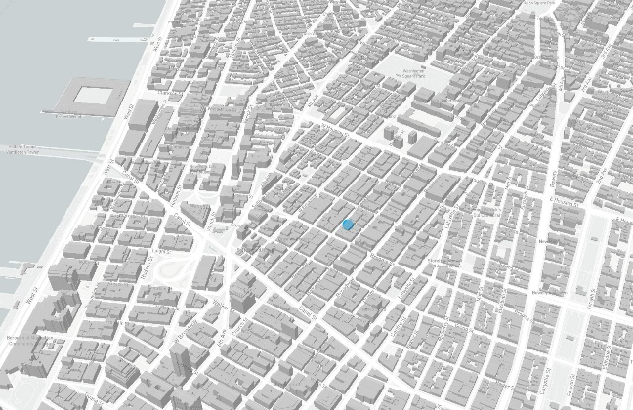**Site Photos**

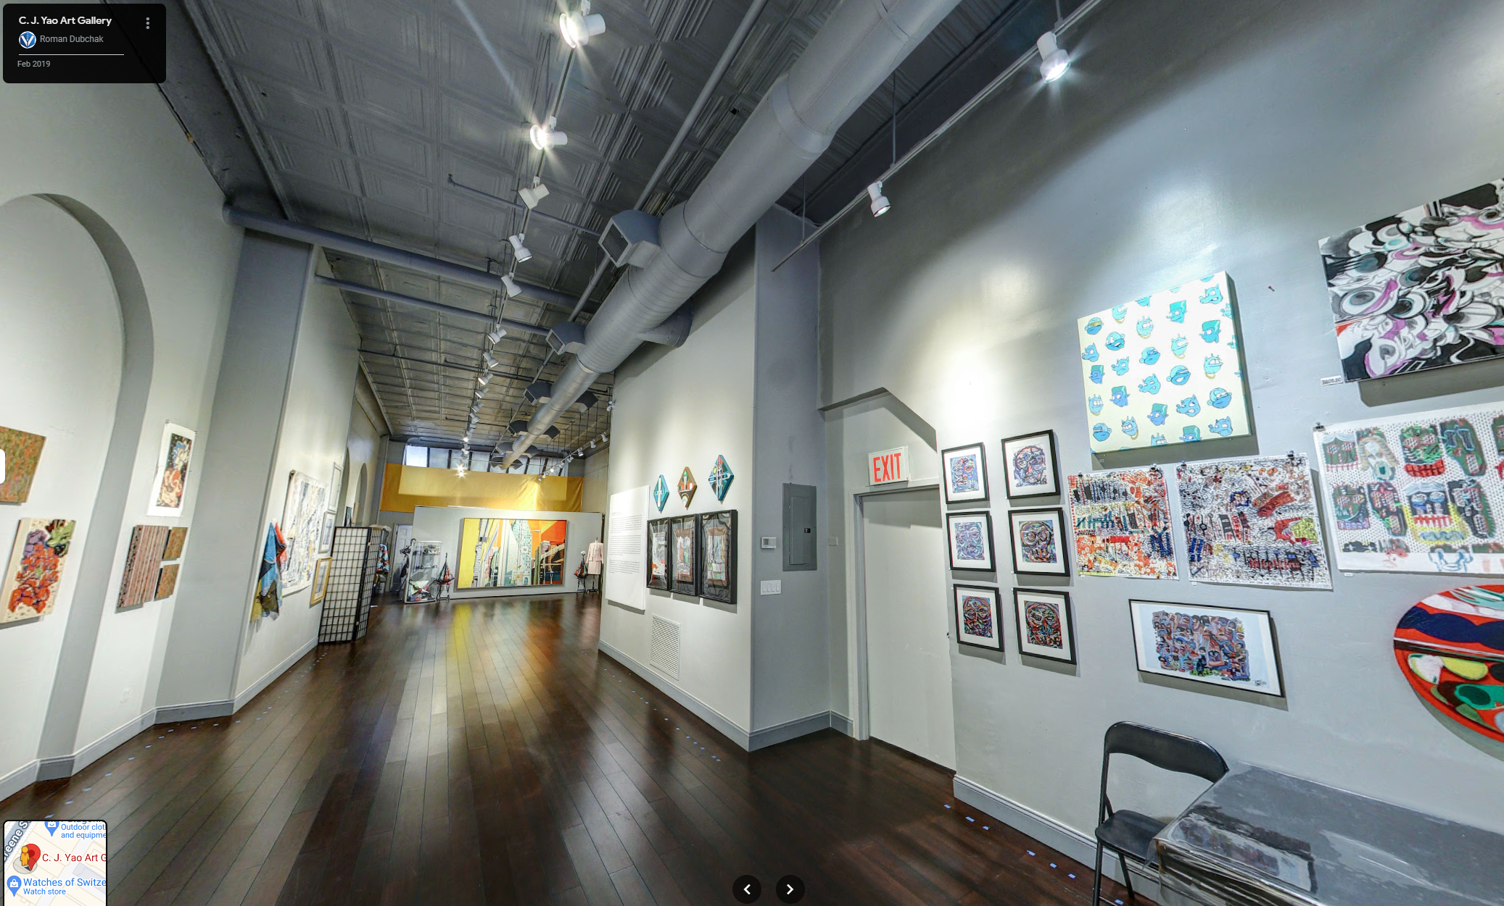

Image Description: Ground Floor Store Image Description: 3D Axon View of Site

Image Date: Feb. 2019 Image Date: 3/14/24

Image Description: Sanborn Map Data – NYC 1890-1902 vol. 1, 1894. Sheet 21a_a

Image Date: 1894

1. **A building with ladders on the side

   Description automatically generatedHistorical Photos (Tax Images, Try to get all maps as image or link)**

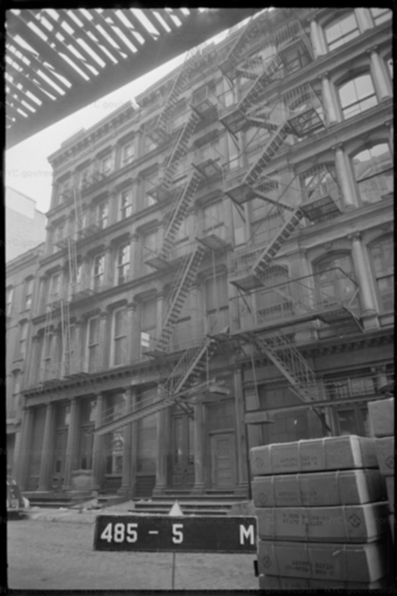

Image Description: Tax lot Image Image Description: Tax lot Image

Image Date: 1940 Image Date: 1980

**Acronym Glossary**

**ACRIS |** Automated City Register Information System

**ALT |** Alteration

**BIN |** Building Information Number

**CCO |** Corporation Counsel Opinion

**CO |** Certificate of Occupancy

**CONH |** Certificate of No Harassment

**DHCR |** Division of Housing and Community Renewal

**ECB |** Environmental Control board

**FAR |** Floor Area Ratio

**HPD |** The Department of Housing Preservation and Development

**LPC |** Landmarks Preservation Commission

**NIC |** Not in Contract

**OATH |** The Office of Administrative Trials and Hearings

**PA |** Places of Assembly

**SLA |** State Liquor Authority

**SPD |** Special Purpose District

**TBIN |** Temporary Building Information Number

**TCO |** Temporary Certificate of Occupancy

**Disclosures & Indemnity**

For Use in New York State Only.

This report ("Report") is for informational purposes only and should not be considered a substitute for professional advice. It is not intended to be used for any decision-making process without independent verification. While the information presented in this Report is believed to be accurate, Azark Inc. does not warrant or guarantee its accuracy or completeness. You, the user, assume full responsibility for verifying all information before taking any action.

The User acknowledges that the Report may contain errors or omissions. Azark Inc. is not liable for any damages, direct, indirect, incidental, consequential, or otherwise, arising from the use of this Report. The User is advised to consult with qualified professionals, including attorneys and inspectors, for their independent assessment of the property.

**Exhibit I – City of New York Department of Records and Information ; Property Card**

**Exhibit II – Landmark Preservation Commission – LPC Docket #24-07975**

66 GREENE STREET

NEW YORK, NEW YORK 10012

AZARK ARCHITECTURE

130 WEST 37TH STREET

NEW YORK NY 10018

**TABLE OF CONTENTS**

I LIST OF DRAWING SHEETS ASSOCIATED WITH LPC DOCKET # 24-07975

II OUTLINE SPECIFICATIONS

PART-1 GENERAL

1.1 Scope of work

1.2 Quality Assurance

1.3 Delivery, Storage and Handling

1.4 Project Conditions

PART-2 PRODUCTS

2.1 Manufacturers

A. Exterior Paint (entire facade)

B. Exterior Paint (existing exterior steps diamond plate)

2.2 Materials

2.3 Mixing and Tinting

PART-3 EXECUTION

3.1 Examination

3.2 Surface Preparation Standards

3.3 Application - General

3.4 Cleaning

3.5 Protection and Repair

3.6 Final Inspection

**END OF SECTION**

**I LIST OF DRAWING SHEETS ASSOCIATED WITH LPC DOCKET# 24-07975**

ARCHITECTURAL

G-100.00 COVER PAGE

G-101.00 GENERAL NOTES

A-100.00 PARTIAL DEMO & PROPOSED PLANS EXTERIOR FAÇADE (1ST – 2ND FLOOR)

A-200.00 EXISTING AND PROPOSED ELEVATIONS, SECTION DETAILS

A-400.00 EXTERIOR FAÇADE CLOEUP PHOTOS AND ENTIRE FAÇADE PHOTO

**II OUTLINE SPECIFICATIONS**

**PART 1- GENERAL:**

* 1. **SCOPE OF WORK:**

Restoration work of existing Historic façade as indicated on drawings:

1. Remove portion of existing exterior & interior stairs as indicated.
2. Repaint existing exterior steps diamond plate finish with same color to match existing.
3. Remove existing commercial entry door & & install new lowered door and solid wood panel above.
4. Remove existing fire escape drop down ladder & install new fire escape extension as indicated.
5. Install new exterior signage as indicated.

**1.2 QUALITY ASSURANCE:**

A. At Contractor option, work may be divided between two levels: One for demolition and the other for installation work.

B. Restoration Specialists to be engaged to perform restoration, demo and cleaning work. Person who are experienced in restoration work types will be performing work.

C. Manufacturer Qualifications: Minimum 5 year experience manufacturing similar products.

D. Installer Qualifications: Installer shall have a minimum of three years proven construction experience and be capable of estimating and building from blueprint plans and details, determining elevations, in addition to proper material handling. All Work shall comply with manufacturer's installation and application procedures.

E. Contractor must obtain all products from a single manufacturer. Any secondary products that are required which cannot be supplied by the specified manufacturer must be recommended and approved in writing by primary manufacturer prior to bidding.

** NOTE TO SPECIFIER ** Include a mock-up if the project size and/or quality warrant taking such a precaution. The following is one example of how a mock-up on a large project might be specified. When deciding on the extent of the mock-up, consider all the major different types of work on the project.

**1.3 DELIVERY, STORAGE AND HANDLING:**

1. Deliver materials properly protected against damage to finished surfaces during transit.
2. Inspect materials upon delivery for damage. Unless minor defects can be made to meet the Architect’s specifications and satisfaction, damaged parts should be removed and replaced.
3. Store materials at building site under cover in dry location

D. Protect products during shipment, storage and construction against damage.

**1.4 PROJECT CONDITIONS:**

* + - * 1. Weather Limitations: Proceed with installation only when existing and forecasted weather conditions permit storefront work to be performed according to manufacturer's written instructions and warranty requirements.
        2. Field Measurements: Verify actual dimensions of storefront installation by field measurements before fabrication.

** NOTE TO SPECIFIER ** Delete if not required.

**IV PART 2- PRODUCTS:**

* 1. MANUFACTURERS

A. Exterior Paint (Entire Façade):

Benjamin Moore

Black: HC – 178

Light Reflection value: 14.51

Collection Name: Historical

B. Exterior Paint (exterior steps diamond plate finish):

Sherman Williams

Black Magic: SW – 6991

Light Reflection value: 3

RGB: 50/ 49/ 50

Hex value# 323132

­Acceptable Manufacturer: Benjamin Moore and Co., which is located at: 101 Paragon Dr Montvale, NJ 07645; Toll Free Tel: 866-708-9181; Email: info@benjaminmoore.com; Web:[www.benjaminmoore.com](http://www.benjaminmoore.com)

­In March 2008, Benjamin Moore finalized the purchase of select assets of Insl‐x Products Corporation, including Insl‐x®, Coronado®, and Lenmar®

1st Coat: Benjamin Moore Fresh Start® High-Hiding All Purpose 046, 44 g/L, 6, 17, 17 X-Green™, 39, 50, 50 X-Green™, 137, 137 X-Green™, Qualifies for LEED® v4 Credit, Qualifies for CHPS low emitting credits

2nd Coat: Benjamin Moore Exterior Regal® Select Exterior Flat W105, Charcoal Slate HC-178, < 50 g/L, 10

3rd Coat: Benjamin Moore Exterior Regal® Select Exterior Flat W105, Charcoal Slate HC-178, < 50 g/L, 10

* 1. MATERIALS
     + 1. Volatile Organic Compound (VOC) Content:
          1. Provide coatings that comply with the most stringent requirements specified in the following:

40 CFR 59, Subpart D-National Volatile Organic Compound Emission Standards for Architectural Coatings.

Determination of VOC Content: Testing and calculation in accordance with 40 CFR 59, Subpart D (EPA Method 24), exclusive of colorants added to a tint base and water added at project site; or other method acceptable to authorities having jurisdiction.

* + - 1. Compatibility: Provide materials that are compatible with one another, and the substrates indicated under conditions of service and application, as demonstrated by manufacturer based on testing and field experience.
  1. MIXING AND TINTING
     + 1. Except where specifically noted in this section, all paint shall be ready-mixed and pre-tinted. Agitate all paint prior to and during application to ensure uniform color, gloss, and consistency.
       2. Thinner addition shall not exceed manufacturer's printed recommendations. Do not use kerosene or other organic solvents to thin water-based paints.
       3. Where paint is to be sprayed, thin according to manufacturer's current guidelines.

** NOTE TO SPECIFIER ** Delete one of the following two paragraphs; coordinate with requirements of Division 1 section on product options and substitutions.

** NOTE TO SPECIFIER ** Tile Tech roof pavers and adjustable pedestal system offers a solution for all roofing and waterproofing needs from standard Roof Ballast and Walkway, to Architectural Plazas and Green Roofs converting them into functional and attractive spaces.

** NOTE TO SPECIFIER ** Granite-Tech™ pavers are produced under extreme hydraulic pressure by bonding crushed granite and limestone together within a color cement matrix duplicating the forces of nature. The pavers are then ground to expose the beauty of the natural granite chips and can be honed or shot blasted resulting in a granite-like, slip resistant and high strength paver.

**V PART 3- EXECUTION:**

**3.1 EXAMINATION:**

A. Contractor to examine existing condition of all different materials along existing exterior façade.

B. Contractor shall review the product manufacturer's special instructions for surface preparation, application, temperature, re-coat times, and product limitations.

C. Contractor shall review product health and safety precautions listed by the manufacturer.

D. Contractor shall be responsible for enforcing on site health and safety requirements associated with the Work.

E. Do not begin installation until substrates have been properly prepared.

F. Coordinate setting drawings, diagrams, templates, instructions, and directions for installation. Coordinate delivery of such items to project site.

**3.2 SURFACE PREPARATION STANDARDS:**

The basic standards for preparing metal substrates are a joint effort between the Society for Protective Coatings (SSPC) and the National Association of Corrosion Engineers International (NACE).

**SSPC-SP1** Solvent Cleaning Removal of all visible oil, grease, soil, drawing and cutting compounds, and other soluble contaminants from steel surfaces with solvent, vapor, cleaning compound, alkali, emulsifying agent, or steam.

**SSPC-SP2** Hand Tool Cleaning Removes all loose mill scale, loose rust, loose paint, and other loose detrimental foreign matter by hand chipping, scraping, sanding, and wire brushing.

**SSPC-SP3** Power Tool Cleaning Removes all loose mill scale, loose rust, loose paint, and other loose detrimental foreign matter by power wire brushing, power sanding, power grinding, power tool chipping, and power tool descaling.

**SSPC-SP5** / NACE 1 White Metal Blast Cleaning When viewed without magnification, the surface shall be free of all visible oil, grease, dust, dirt, mill scale, rust, coating, oxides, corrosion products and other foreign matter.

**SSPC-SP6** / NACE 3 Commercial Blast Cleaning When viewed without magnification, the surface shall be free of all visible oil, grease, dust, dirt, mill scale, rust, coating, oxides, corrosion products and other foreign matter of at least 66-2/3% of unit area, which shall be a square 3 in. x 3 in. (9 sq. in.). Light shadows, slight streaks, or minor discolorations caused by stains of rust, stains of mill scale, or stains of previously applied coating in less than 33-1/3% of the unit area is acceptable.

**SSPC-SP7** / NACE 4 Brush-Off Blast Cleaning When viewed without magnification, the surface shall be free of all visible oil, grease, dirt, dust, loose mill scale, loose rust, and loose coating. Tightly adherent mill scale, rust, and coating may remain on the surface. Mill scale, rust, and coating are considered tightly adherent if they cannot be removed by lifting with a dull putty knife.

**SSPC-SP10** / NACE 2 Near-White Blast Cleaning When viewed without magnification shall be free of all visible oil, grease, dust, dirt, mill scale, rust, coating, oxides, corrosion products and other foreign matter of at least 95% of each unit area. Staining shall be limited to no more than 5 percent of each unit area, and may consist of light shadows, slight streaks, or minor discolorations caused by stains of rust, stains of mill scale, or stains of previously applied coatings. Unit area shall be approximately 3 in. x 3 in. (9 sq. in.).

**SSPC-SP11** Power Tool Cleaning to Bare Metal When viewed without magnification, the surface shall be free of all visible oil, grease, dirt, dust, mill scale, rust, paint, oxides, corrosion products, and other foreign matter. Slight residues of rust and paint may be left in the lower portion of pits if the original surface is pitted. The surface profile shall not be less than 1 mil (25 microns).

**SSPC-SP12** / NACE 5 Surface Preparation and Cleaning of Steel and Other Hard Materials by High- and Ultra High- Pressure Water Jetting Prior to Recoating This standard requires water jetting at high- or ultra high-pressure to prepare a surface for recoating using pressure above 10,000 psi. Water jetting will not produce a profile; rather, it exposes the original abrasive-blasted surface profile. Water jetting shall be performed to meet four conditions: WJ-1, WJ-2, WJ-3, and WJ-4, and a minimum acceptable surface shall have all loose rust, loose mill scale, and loose coatings uniformly removed.

**SSPC-SP13** / NACE 6 Surface Preparation of Concrete Provides requirements for surface preparation of concrete by mechanical, chemical, or thermal methods prior to the application of bonded protective coating or lining systems.

**SSPC-SP14** / NACE 8 Industrial Blast Cleaning Removal of all visible oil, grease, dust and dirt, when viewed without magnification. Traces of tightly adherent mil scale, rust, and coating residues are permitted to remain on 10% of each unit area of the surface if they are evenly distributed. Shadows, streaks, and discoloration caused by stains of rust, stains of mill scale, and stains of previously applied coating may be present on the remainder of the surface.

**3.3 APPLICATION – GENERAL:**

1. Application of primers, paints, stains or coatings, by the Contractor, will serve as acceptance that surfaces were properly prepared in accordance with the manufacturer's recommendation.
2. Apply each coat to uniform coating thickness in accordance with manufacturer's instructions, not exceeding manufacturer's specified maximum spread rate for indicated surface; thins, brush marks, roller marks, orange-peel, or other application imperfections are not permitted.
3. Allow manufacturer's specified drying time, and ensure correct coating adhesion, for each coat before applying next coat.
4. Inspect each coat before applying next coat; touch-up surface imperfections with coating material, feathering, and sanding if required; touch-up areas to achieve flat, uniform surface without surface defects visible from 5 feet (1.5 m).
5. Remove dust and other foreign materials from substrate immediately prior to applying each coat.
6. Where paint application abuts other materials or other coating color, terminate coating with a clean sharp termination line without coating overlap.
7. Where color changes occur between adjoining spaces, through framed openings that are of same color as adjoining surfaces, change color at outside stop corner nearest to face of closed door.
8. Re-prepare and re-coat unsatisfactory finishes; refinish entire area to corners or other natural terminations.

**3.4 CLEANING:**

1. Clean glazing surfaces after installation, complying with requirements contained in the manufacturer’s instructions. Remove excess glazing sealant compounds, dirt or other substances.
2. Remove protective films from any hardware, exterior light fixtures surfaces.

C. New installed storefront: Spot cleaned gently by hand with water and clean cloth.

E. New exterior light fixtures: Clean with low-pressure water wash and let it air dry.

F. Adjust all products, sash, vents, and hardware after installation, as necessary to provide proper operation and a weather tight installation

G. Remove any labels and dirt from the storefront.

**3.5 PROTECTION AND REPAIR:**

1. Protect completed coating applications from damage by subsequent construction activities until completion of painting project.
2. Touch-up coatings damaged by subsequent construction activities.

**3.6 FINAL INSPECTION**

A. The completed installation shall have the acceptance of the Architect, Engineer and the Owner.

B. Upon completion of restoration work, remove tools, equipment, and other unnecessary materials from site. Return adjacent area to the clean condition, which existed prior to the start of work. Remove and legally dispose off-site all debris, rubbish, and other materials resulting from restoration work.

**END OF SECTION**

* + # of exits
  + Fire escape
  + Applicable codes
  + NFPA
* LNO – Letter of No Objection
* CCD1-DOB Waivers/approvals
* Fireproof or Nonfireproof Building
* Led, Mold, Asbestos
* Fire Line
* Domestic Line
* Double check valve, RPZ (Residential)
* Combination Line
* List of Uses by floor. (Are these compliant or not)
* What is the legal use of each floor
* ‘Schedule A’ Certificate of Occupancy

Tenant’s List

Lot Reapportionment

Two diff tax lots, diff zoning lots

Required Signage

Light and Vent requirements for residential for the staircase specifically

* + Office of Environmental Remediation

Environmental Restrictive Declaration or ‘E’ Designation (yes/no)

Remedial Action Plan Required?:

Noise and/or Air Quality Designation?:

* + Air Rights

Applicable Sky Exposure Plane(yes/no):

Horizontal Building Distance from Street Line: ____

Vertical Height from base plane set forth in District Regulations: ____

Present Obstructions (i.e. Fire Escapes, Chimneys, flagpoles, skylight, vegetated roofs):

* + Loft Board Building (yes/no):

JLWQA (Joint Living Work Quarters for artists):

IMD Registration # (Interim Multiple Dwelling):

Legalization:

* + Rent Stabilized Building?: